CUSTOMER SHOPPING BEHAVIOUR ANALYSIS
- Project Overview
This project analyzes customer shopping behaviour using transactional data from 3900 purchase across various product categories. The goal is to uncover insights into spending patterns, customer segments, product preferences, and subscription behaviour to guide strategic business decisions.

- Dataset Summary
- Rows – 3,900
- Columns – 16
- Some Key Features:
  - Customer demographics (Age, Gender, Location, Subscription Status)
  - Purchase details (Item Purchased, Category, Purchase Amount, Season, Size, Color)
  - Shopping behaviour (Discount Applied, Previous Purchase, Frequency of Purchase, Review Rating)

- Exploratory Data Analysis using Python
We began with data preparation and cleaning in Python:
  - Data Loading – Imported the dataset using pandas.
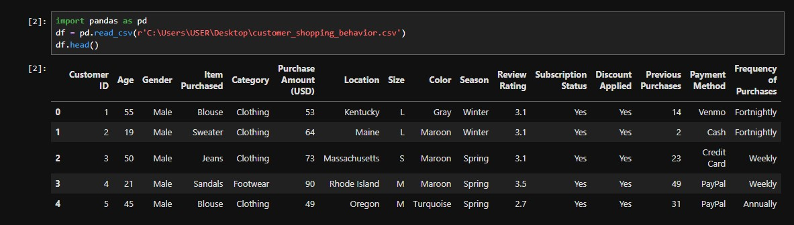
  - Initial Exploration – Used df.info() to check data structure and df.describe() for summary statistics

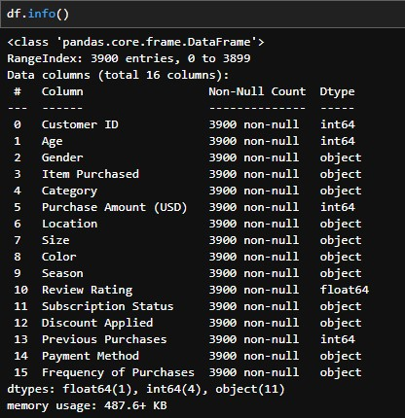

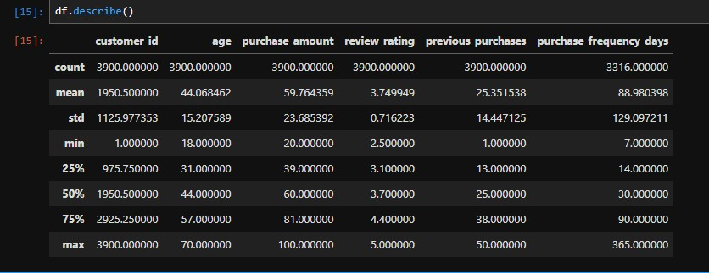
  - Missing Data Handling – Checked for null and missing values
  - Column Standardization – Renamed columns to snake case for better readability and documentation.
  - Feature Engineering:
    - Created age_group column by binning customer ages.
    - Created purchase_frequency_days column from purchase date.

- Data Analysis using SQL
We performed structured analysis in MySQL Workbench to answer key business questions:
  - Revenue by Gender – Compared total revenue generated by male vs female customers.
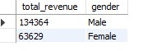
  - High-Spending Discount Users – Identified customers who used discounts but still spent above the average purchase amount.

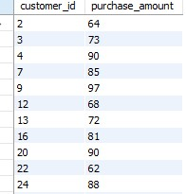

  - Top 5 Products by Rating – Found products with the highest average review ratings.

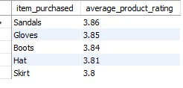

  - Subscribers vs Non-Subscribers – Compared average spend and total revenue across subscription status.

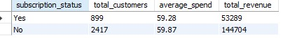

  - Discount-Dependent Products – Identified 5 products with the highest percentage of discount purchases.

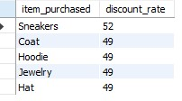

  - Customer Segmentation – Classified customers into New, Returning and Loyal segments based on purchase history.

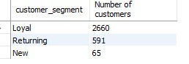

  - Top 3 Products Per Category – Listed the most purchased products within each category.

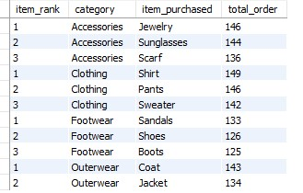
  - Repeat Buyers and Subscriptions – Checked whether customers with more than 5 purchases are more likely to subscribe.

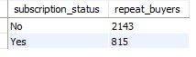

  - Revenue by Age Group – Calculated total revenue contribution of each age group.

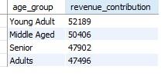

- Dashboard in Power BI
Finally, we built an interactive dashboard in Power BI to present insights visually
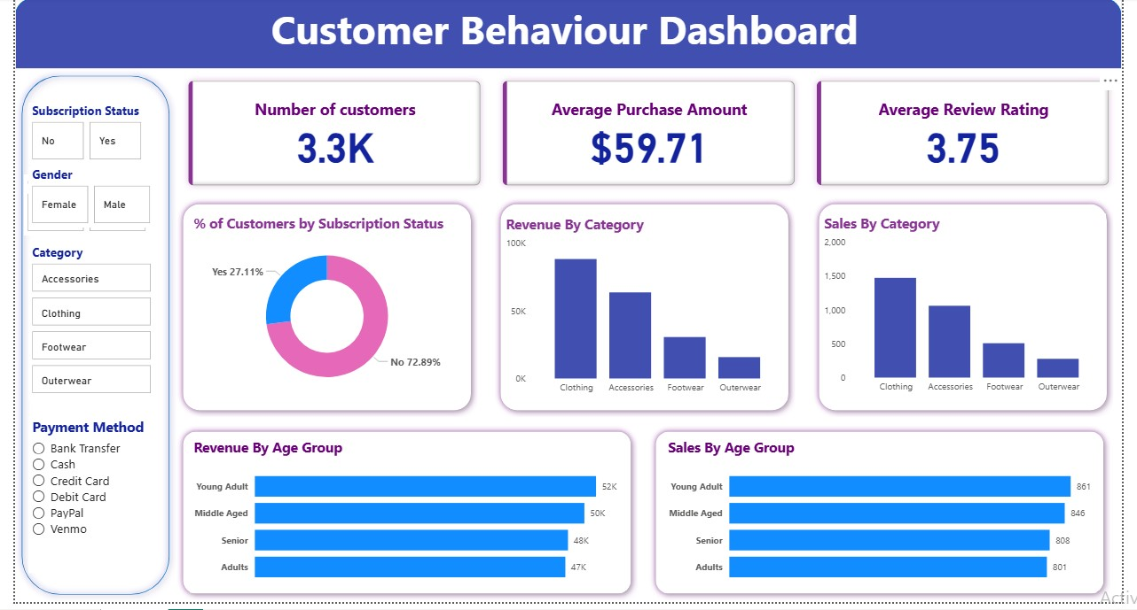

- Business Recommendations
- Boost Subscription – Promote exclusive benefits for subscribers.
- Customer Loyalty Programs – Reward repeat buyers to move them into the Loyal segments.
- Review Discount Policy – Balance sales boosts with margin control.
- Product Positioning – Highlight top rated and best-selling products in campaigns.
- Targeted Marketing – Focus efforts on high-revenue age-group

